Docker Commands Lab: Managing Containers and Images
In this hands-on lab, we will learn docker commands to manage docker containers and images.

Pre-Requisite
- A VM with Docker Installed

Steps to Follow

Create a Test Container:
docker run -d -p 80:80 --name mycontainer nginx:latest

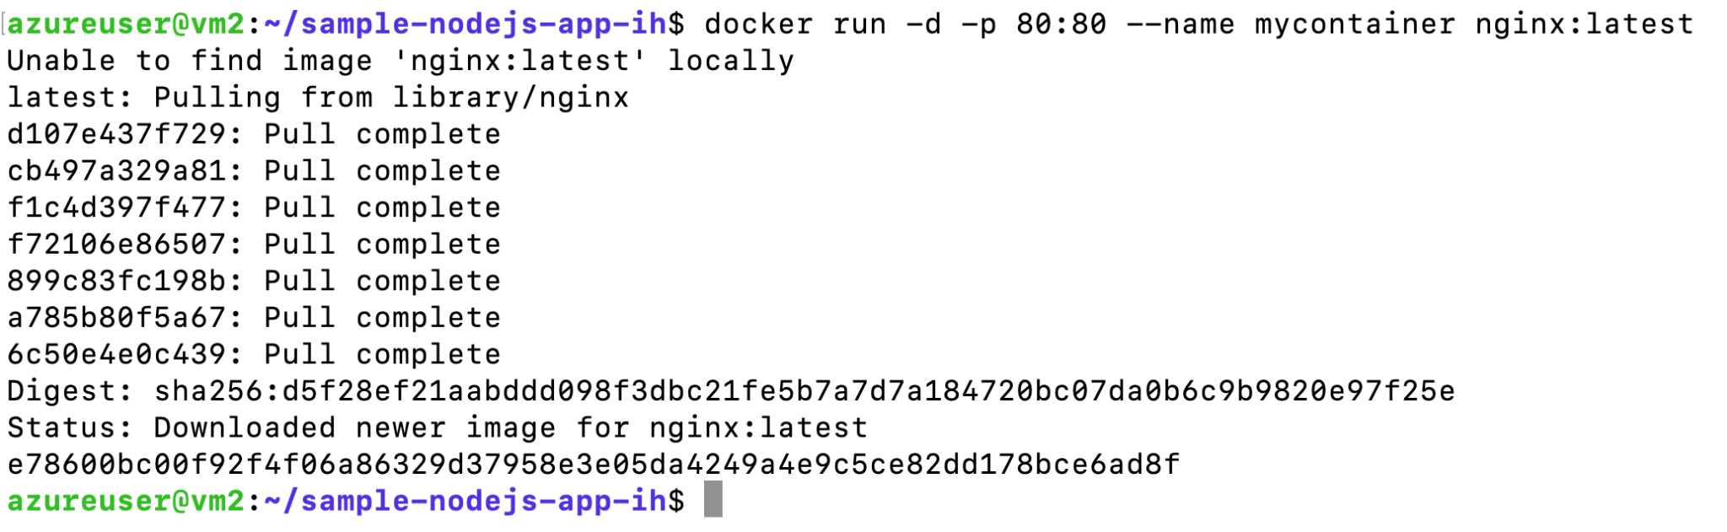
This command downloads the docker image (if not already present) and runs a container named "mycontainer".
The -d flag runs the container in "detached" mode (in the background).
The output will be a long container ID string, indicating the container has been created and is running.

List Running Containers:
Use the docker ps command to list all containers currently running. For example:
docker ps

The output shows a table of running containers with columns for CONTAINER ID, IMAGE, COMMAND, CREATED, STATUS, PORTS, and NAMES. In this case, you should see the mycontainer container running the nginx image. (If no containers are running, the list will be empty.)
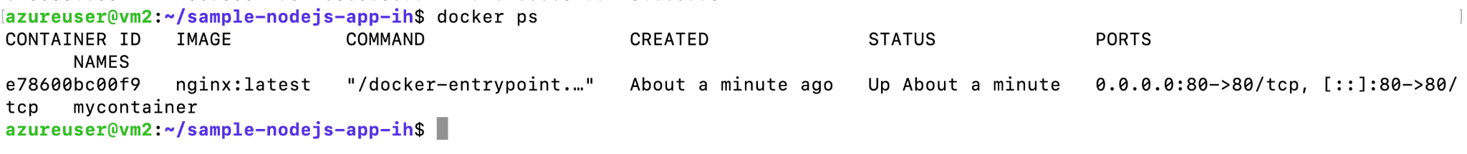

Stop the Running Container
docker stop mycontainer

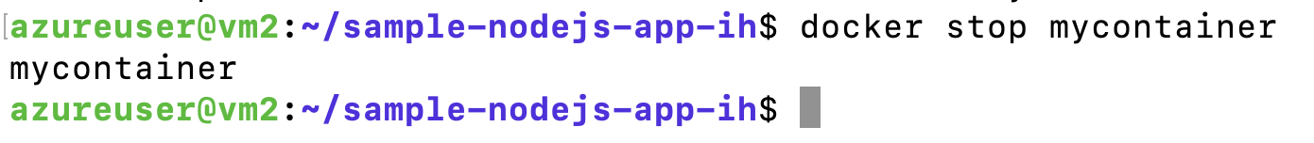
This command will stop the container myContainer. If you run the docker ps command, you will not see the container anymore in the list.

List All Containers (Including Stopped):
By default, docker ps shows only running containers. To see all containers (running and stopped), use docker ps -a. For example:
docker ps -a
In this output, you might see the containers that have exited. The STATUS column tells you whether each container is Up (running) or Exited (stopped) and how long ago. Here, for example, "temporary-container" exited 90 seconds ago, whereas "mycontainer" is still Up.

Inspect a Container
Docker allows you to inspect a container's details using docker inspect.
This command returns low-level information about the container in JSON format.
Try inspecting the container you just stopped:
docker inspect mycontainer

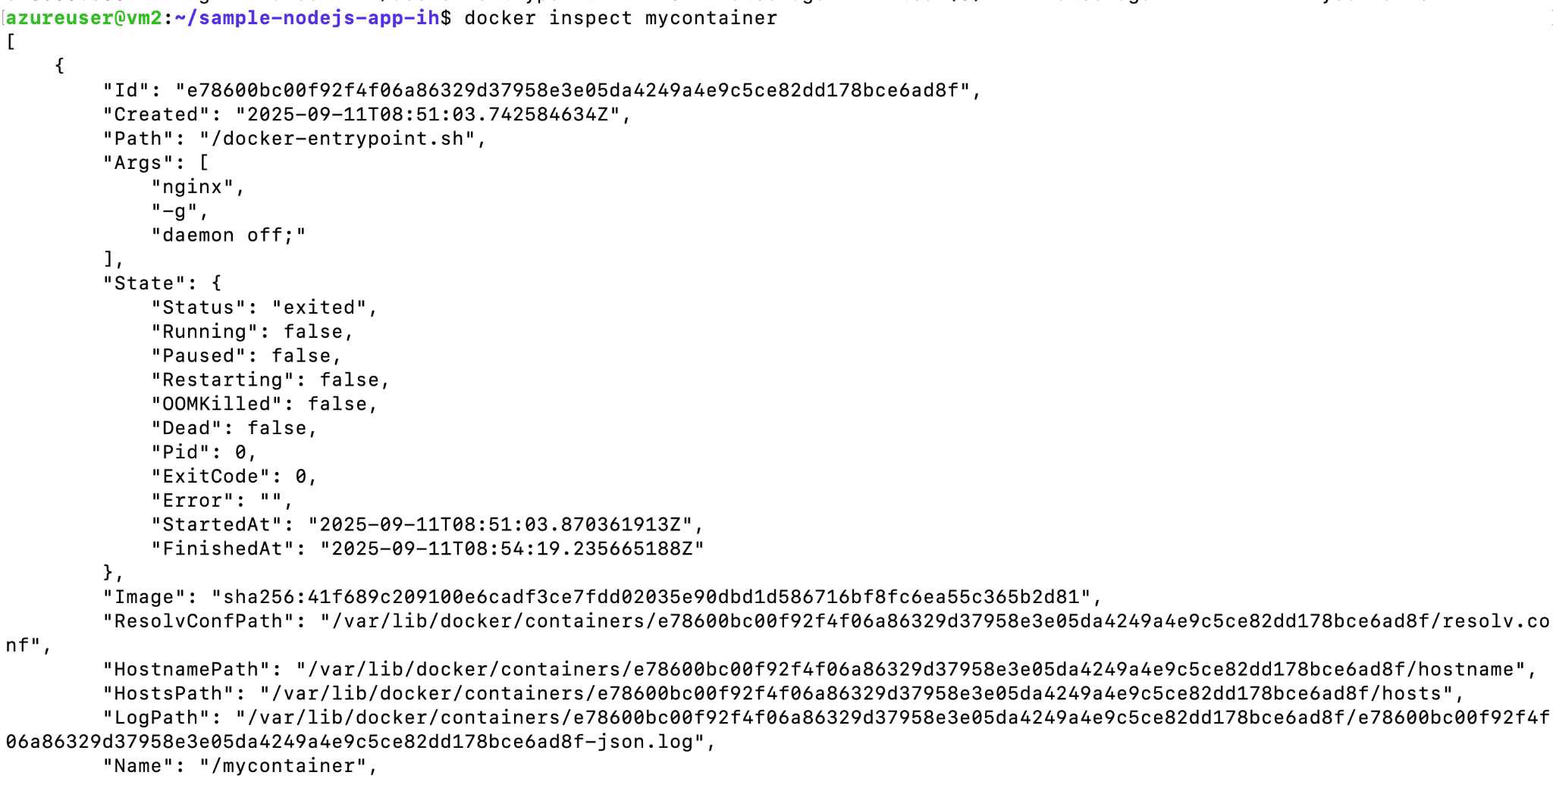
The output is a JSON array containing detailed properties of mycontainer.
It includes information such as the container’s configuration, environment variables, network settings, mount points, and the command it was running. (By default the JSON is lengthy. You can add the --format option to filter specific fields if needed.) This inspect command works for both running and stopped containers – it’s a useful way to retrieve configuration details and metadata about a container.

Start a Stopped Container:
To start a container that is not running, use docker start followed by the container name or ID. This will take a container in Exited status and run it again (the container retains its previous state and configuration). For example:
docker start mycontainer
Docker will output the container name (or ID) to indicate it has been started. The container’s status becomes “Up”. If you run docker ps, mycontainer will appear as running again. (In our example, the nginx container will resume and continue the sleep command).

Restart a Container:
The docker restart command is a convenient way to reboot a container – it stops the container (if running) and then starts it again immediately. Ensure the container is running, then try:
docker restart mycontainer

This will briefly stop mycontainer and then start it again. The output shows the container name, confirming the restart. You can think of this as a quick way to apply changes or recover a container by cycling it off and on. After a restart, docker ps will still show the container as Up (with a fresh uptime).

Remove a Container:
When you no longer need a container, you can remove it with docker rm. Important: A container must be stopped before it can be removed (you cannot remove a running container without forcing it).
First, ensure mycontainer is stopped:
docker stop mycontainer # Stop if it's still running

docker rm mycontainer

The docker rm command deletes the container permanently.

List Docker Images:
To manage images, let's start by listing the images on your system. Use the docker images command (which is the same as docker image ls) to see all local images. For example:
docker images

This output shows each image’s repository (name), tag, IMAGE ID, when it was CREATED, and its SIZE.

Inspect an Image:
Just like containers, images can be inspected. Use docker inspect with an image name (or ID) to see its details. For example, inspect the nginx image:
docker inspect nginx:latest

This will output a JSON description of the nginx:latest image. The information includes the image’s ID, architecture, creation time, size, and configuration (such as environment variables, default command, and entrypoint).
Inspecting images is useful to see how an image was built or what default settings it has (for instance, what command will run by default when a container is started from it).
As with containers, the output is in JSON; you can parse or search through it to find specific details (for example, the default Cmd or Entrypoint of the image).

Tag an Image:
Tagging an image creates an additional name for the same image. This is useful for versioning or pushing to a registry under a different name. Use the docker tag command with the source image and the new target name:
docker tag nginx:latest mynginx:v1

This command creates a new tag mynginx:v1 that refers to the same image as nginx:latest. There is no direct output if it succeeds (it will silently create the tag).
Now the nginx image on your system has two references: one as nginx:latest and one as mynginx:v1.
Tagging does not duplicate the image data; it simply adds another label to the same image ID.
Verify the New Image Tag:
Run docker images again to see the updated list of images:
docker images

You should see mynginx:v1 listed alongside nginx:latest, with the same IMAGE ID.
Remove an Image Tag (or Image):
If you want to remove an image, use docker rmi. For instance, let's remove the tag we just created:
docker rmi mynginx:v1
This command removes the mynginx:v1 tag. Docker indicates this by saying "Untagged". The image data is not deleted because it still has the other tag (nginx:latest) referencing it.

Clean Up Dangling Images:
Over time, you might accumulate dangling images – these are images layers that have no tags (for example, <none>:<none> entries) and are not needed. Docker provides a command to remove dangling images:
docker image prune

This will interactively prompt for confirmation: Docker will warn "This will remove all dangling images" and ask you to continue (press y to confirm). After confirmation, Docker deletes any image layers that are not referenced by any image tag.

Clean Up Unused Containers and Images:
To go a step further in cleaning up, Docker has a broader cleanup command:
docker system prune -a

This command removes all stopped containers, unused networks, dangling images, and (with the -a flag) any images not currently used by running containers. It’s a quick way to free up space. Like the prune command above, it will ask for confirmation.

